

**FOR PAYMENT USE**

 



Cheque No: ……………  
Amount Paid: ……………

Signature: ……………

Invoice # 10723802943000  
Billing Month: MAY, 2019   
Due Date: IMMEDIATE  
Total Amount Due: Rs. 5100.00

Customer ID: 0439200401884-51  
Account ID: 1992332580  
Phone No: 0992-401884-51 CK:9

PTCL STN: 07018517013496  
PTCL NTN: 0801599-6

**DEAR CUSTOMER, YOUR BILL HAS APPEARS, KINLDY PAY THE BILL IMMEDIATELY TO CONTINUE ENJOYING UN-INTERRUPTED SERVICES**

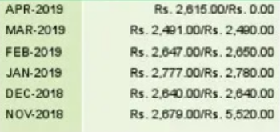

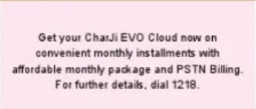

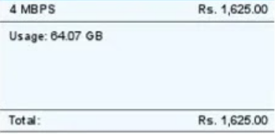



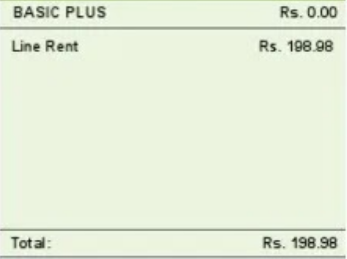

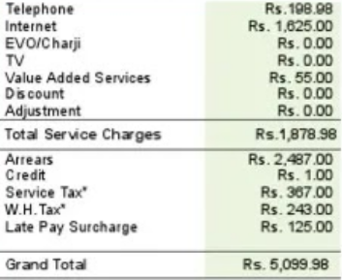

**BILLED/PAID HISTORY**

**EVO/CHAR JI**

**INTERNET**

|  |  |
| --- | --- |
| Account ID /ESN | 1992332580 |
| Billing Month | May, 2019 |
| Amount Due | **Rs. 5100.00** |
| Due Date | **OVERDUE** |

**BILL SUMMARY**

**TELEPHONE**

**TV**

**SERVICES DETAIL**

DEAR CUSTOMER, YOUR BILL HAS APPEARS, KINDLY PAY THE BILL IMMEDIATELY TO CONTINUE ENJOY! NO UNIT ERRUPTED SERVICES.

Customer NTN/STN/CNIC:   
1310144697197

Invoice # 10723802943000  
Issue Date: 03-06-2019

**INVOICE**

**Pakistan Telecommunication  
Company Limited**

**PTCL STN:** 07018517013496 **PTCL NTN:** 0801599-6

0992-401884

**MUHAMMAD HUZAIFA**

HOUSE NO 14 , , STREET 14 , BILAL TOWN ,  
ABBOTTABAD

**SAY NO TO CORRUPTION**

**www.ptcl.com.pk**